# MVC Page Lifecycle

## Overview

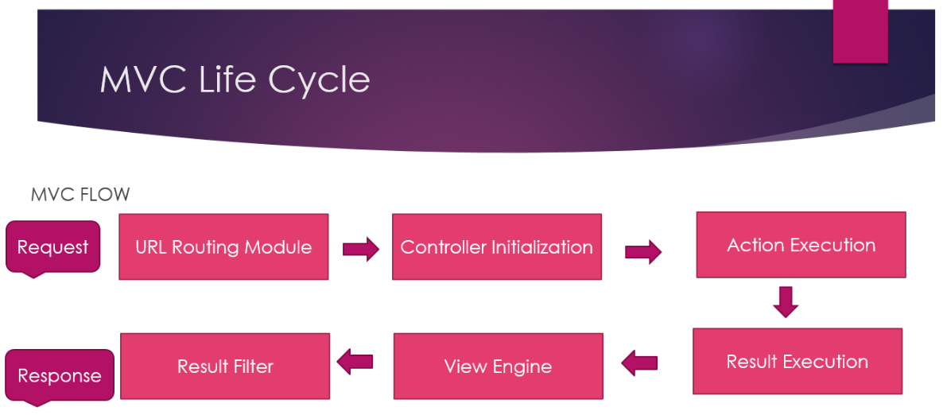

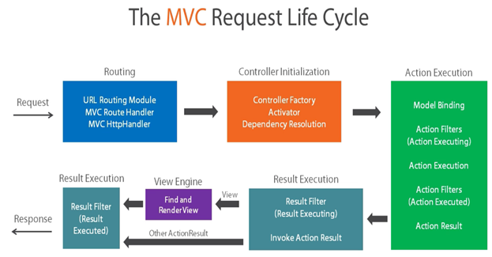

## In-Depth

<https://blogs.msdn.microsoft.com/varunm/2013/10/03/understanding-of-mvc-page-life-cycle/>

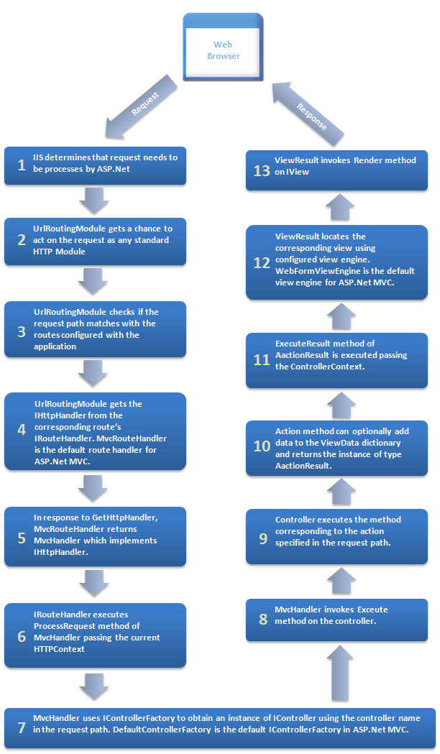

# MVC Filters

Each filter type is executed at a different stage in the filter pipeline:

* Authorization filters
  + They run first and are used to determine whether the user is authorized for the request. Authorization filters short-circuit the pipeline if the request is unauthorized.
* Resource filters:
  + Run after authorization.
  + OnResourceExecuting() can run code before the rest of the filter pipeline. For example, OnResourceExecuting() can run code before model binding.
  + OnResourceExecuted() can run code after the rest of the pipeline has completed.
* Action filters
  + They can run code immediately before and after an individual action method is called. They can be used to manipulate the arguments passed into an action and the result returned from the action. Action filters are **not** supported in Razor Pages.
* Exception filters
  + They are used to apply global policies to unhandled exceptions that occur before anything has been written to the response body.
* Result filters
  + They can run code immediately before and after the execution of individual action results. They run only when the action method has executed successfully. They are useful for logic that must surround view or formatter execution.

The following diagram shows how filter types interact in the filter pipeline.

|  |  |
| --- | --- |
| How filter types interact in the filter pipeline | Order of Invocation: |
|  | Order of execution of filters - Action Filters |

## The Scope of Action Filters

Like the other types of filters, the action filter can be added to different scope levels: Global, Action, Controller.

If we want to use our filter globally, we need to register it inside the AddMvc() method in the ConfigureServices() method:

|  |  |
| --- | --- |
|  | services.AddMvc(    config =>    {       config.Filters.Add(new GlobalFilterExample());    }); |

But if we want to use our filter as a service type on the Action or Controller level, we need to register it in the same ConfigureServices() method but as a service in the IoC container:

|  |  |
| --- | --- |
|  | services.AddScoped<ActionFilterExample>();  services.AddScoped<ControllerFilterExample>(); |

Finally, to use a filter registered on the Action or Controller level, we need to place it on top of the Controller or Action as a ServiceType:

|  |  |
| --- | --- |
|  | namespace AspNetCore.Controllers  {      [ServiceFilter(typeof(ControllerFilterExample))]      [Route("api/[controller]")]      [ApiController]      public class TestController : ControllerBase      {          [HttpGet]          [ServiceFilter(typeof(ActionFilterExample))]          public IEnumerable<string> Get()          {              return new string[] { "example", "data" };          }        }  } |